**Life Cycle Chart**

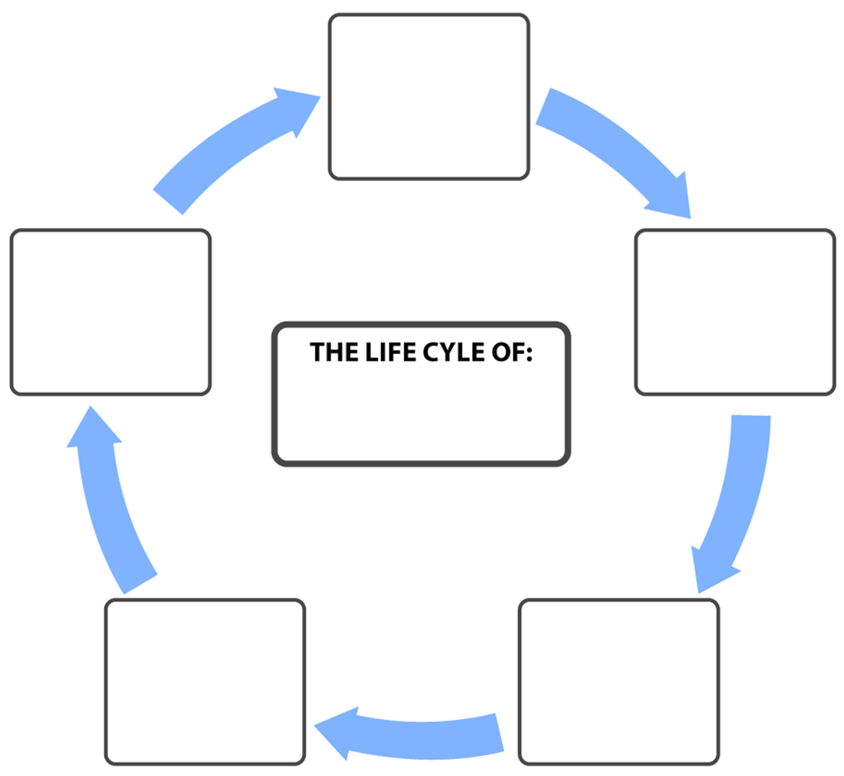

Name here

Type here

Type here

Type here

Type here

Type here